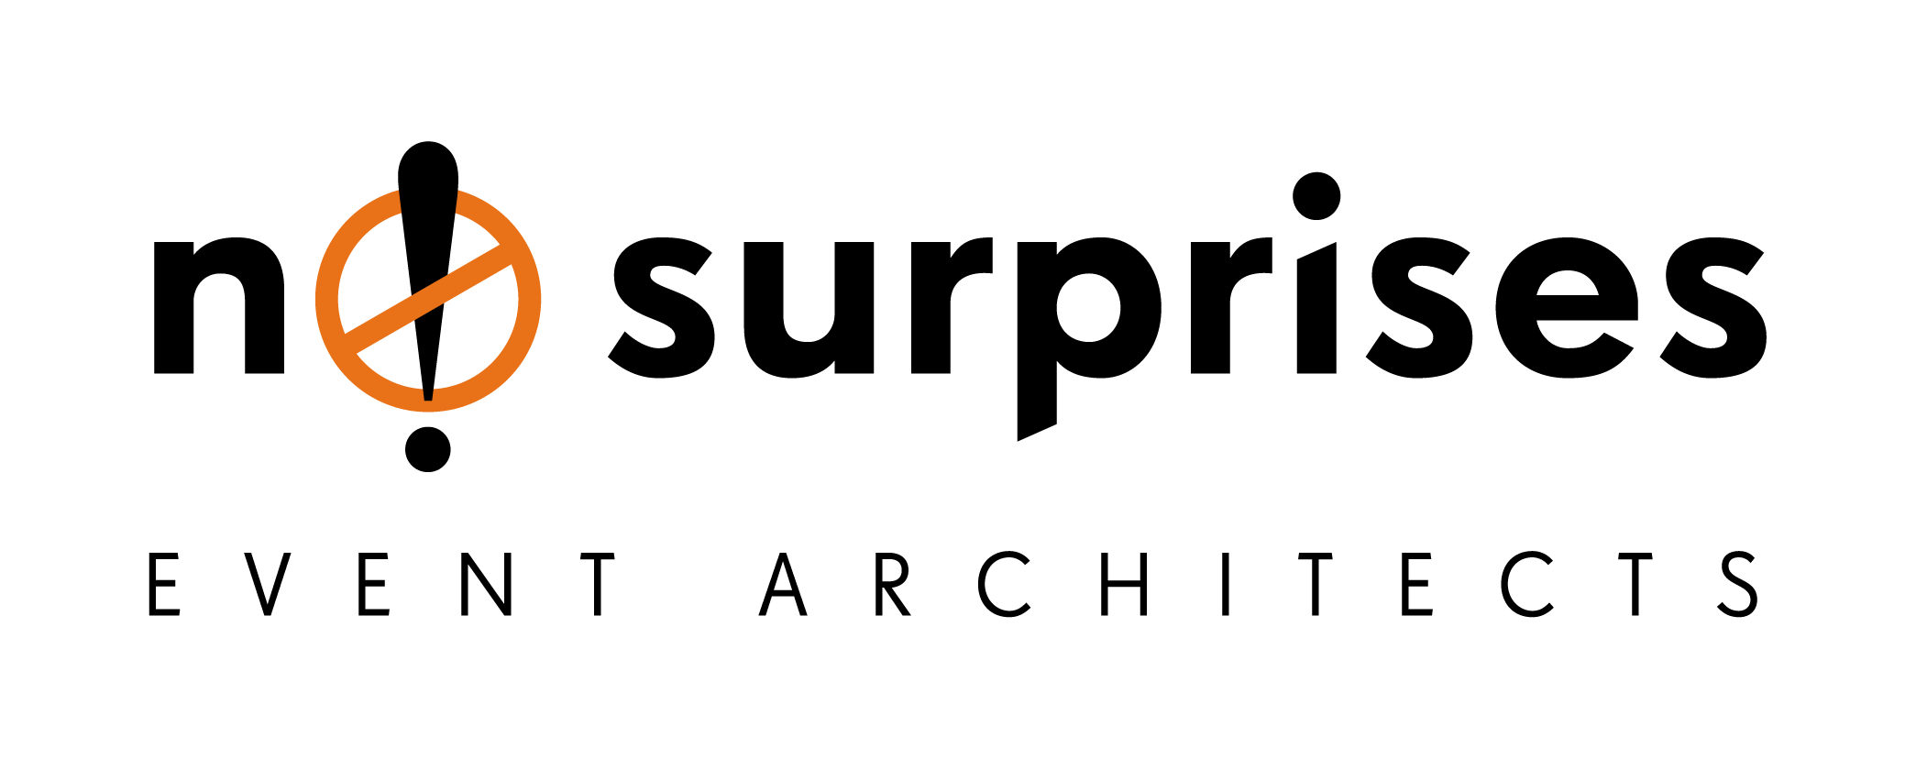

**Now you have a lead, what next?**

How do you convert a lead from one who may be skeptical about the NS high-end brand to one who buys? How do you overcome a poor first impression?

**. Introductory email and Corporate Profile**

**The letter of introduction is the first step in a hopefully profitable relationship**. The objective of the introduction is to give the lead a reason to want to know more about NS, company and the service we are introducing. It’s giving the lead a sneak peek into our brand’s look and feel; who we are and what we can do.

**. Nurture the Relationship**

**The next step is to nurture a relationship with your prospect through email, or other assets that shine a positive light on your brand.** Use each call and meeting to make things more personal. By understanding your clients' lifestyles, you will be better able to meet their needs with your products and services. In turn, you will be able to show them how well our product suits them and how much they need what our business has to offer.

**. Schedule a Semi-Professional “Pitch” Meeting** 

**Once a relationship has been established, find the right time to sell NS through an “intimate” channel.** Speak one-to-one with your prospect. It’s critical to understand your typical clients in order to make the best pitch. Who are they? Why do they need your solution? How does your solution fulfill their needs? Present your product or service so it stands out from the (non) competition.

**. Define and Identify the Lead’s Stage**

**Study the existing client base to identify the steps you took to prior to closing a deal.**

**Lead:** A lead is company you have not yet contacted. This should be based on the profile of the clients your existing client base.

**Qualified prospect:** This is a prospect that fits most if not all of your pre-qualification criteria; they currently use or would benefit from your product or service

**Active prospect:** Through discussion, you have identified that a prospect has a need for your service and they in turn have confirmed an interest in your offering. **Committed prospect:** Commitment to move forward may come in the form of verbal commitment however; you may still be in the process of ironing out the details.

**Closed:** A sale has transpired when a contract is signed by both parties and delivery dates have been confirmed.

**. Stay Top of Mind**

# Develop a rhythm for engaging your clients weekly, monthly, quarterly, and yearly, and you will see client retention soar.

# 